Vectors

- (a)Calculate the angle between “r” and the positive z-axis. (b) Find the angle between “a” and “b”. where a = 5i +4j -6k , b= -2i +2j+3k and c = 4i+3j+2k , r = a+b+c.
- (a) What is the sum in unit vector notation of the two vectors A= 5i +3j and B = -3i + 2j ? (b) What are the magnitude and direction of A+ B ?
- A heavy piece of machinery is raised by sliding it 13 m along a plank oriented at 22° to the horizontal, as shown in figure#1. (a) How high above its original position is it raised? (b) How far is it moved horizontally?

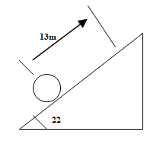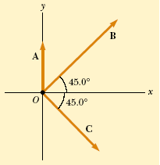
- Three vectors are oriented as shown in Figure-2, where A = 20units, B= 40units, and C = 30units. Find (a) the x and y components of the resultant vector (expressed in unit–vector notation) and (b) the magnitude and direction of the resultant vector
- (a)What are the components of a vector A in the xy plane if its direction is 252°degree counter clockwise from the positive x axis and its magnitude is 7.34 units? (b) The “x” component of a certain vector B is -25 units and “y” component is +43 units. What are the magnitude of the vector and angle between its direction and the positive x axis?
- A sailboat sail 7mi in the direction 37° north of East, then 4mi in the direction 53° West of North. What is the magnitude and direction of the final leg that will bring it to the starting point?
- A vector displacement A in the xy plane has an x component of 10m. The angle between the y and the vector A is 37°. What is the magnitude of the vector A?
- Vector A and B have magnitudes of 3m and 4m, respectively , and are 30° apart. (a)Find the A.B and the magnitude of AxB. (b)Find the A.B and |AxB if both vectors are 137° apart.
- The resultant R of the two vectors A and B has half the magnitude of A and is perpendicular to B. If the magnitude of A is 5, what is the magnitude of B and the angle between A and B?
- Find the angle betwenn the vector A= 2i -3j+5k and the x, y,and z axes, respectively.

